Phy 150: Physics Project 2

Austin Niwa

[Austin.niwa@snhu.edu](mailto:Austin.niwa@snhu.edu)

SNHU

1.The first of newton's laws is if an object is at a rest state it will stay that in a rest state unless acted upon by an outside force. It can also apply to objects in motion as the object will stay in motion at the speed it is in unless a force acts upon it as well.

In this case, the phone is in a rest state until it is dropped then it is acted upon by the force of gravity as it falls. Once it hits the ground it is acted upon by the grounds neutral force as well as gravity during the impact.

Newtons second law is the equation force = mass times acceleration

This second law is the most important one for this project as it is how I will be able to get the force of impact on the phone with and without the cases.

The third law of motion is the one most people think about when they hear of the laws of motion. For every action there is an equal and opposite reaction. When an object exerts a force on another object the other object also exerts a force that is equal and opposite to the force from the first object

This law comes into effect when the phone hits the ground. As the force of gravity forces the phone to hit the ground the ground has an equal neutral force reaction on the phone.

2.I will be using a drop height of 1.5 meters for this project.

Phone with no case starts with 6.2oz

multiply by 28.34952 to 175.75g

divide by 1000 to get 0.17575kg

Silicone case 6.2oz + 1.7oz

7.9oz

Convert to grams 7.9 x 28.34952

223.961208/1000

Mass = .223961208kg

Hard plastic 6.2oz + 1.1oz

7.3oz

Convert to grams 7.3 x 28.34952

206.951496g/1000

.206951496kg

Rubber 6.2 oz + 3.2oz

9.4oz

Convert to grams 9.4oz x 28.34952

266.485488g/1000

.266485488kg

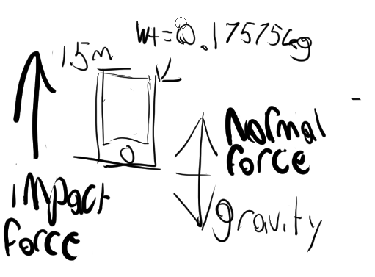

3&4.For the phone without a case

Vf^2 – vi^2 = 2 acceleration(object in free fall so 9.8) distance

Vf^2 –0 = 2(9.8) m/s^2 (1.50)m

Vf^2 = 29.4 m/s^2

vf = 5.422 m/s^2

Mass = 0.17575kg

Acceleration = vf = vi + at

0 = 5.42 + a(0.01)s

-5.42=a(0.01)s

A= -542

Formula for net force mass gravity – net force = mass acceleration

0.17575kg(9.8)m/s^2-n=(0.17575)kg(-542)m/s^2

1.72235-n= -95.2565

-96.97885

NF=-96.98

Net force Impact Force and Gravity are affecting the phone at the time of impact

F = MA

F = -542(0.17575)

Impact Force = 95.2565 N

Silicone case 6.2oz + 1.7oz

7.9oz

Convert to grams 7.9oz x 28.34952g

223.961208/1000

Mass = .223961208kg

Vf^2 – vi^2 = 2 acceleration object in free fall so 9.8) distance

Vf^2 –0 = 2(9.8)(1.50)

Vf^2 = 29.4 sqrt

Vf = 5.422m/s^2

Acceleration = vf = vi + at

0 = 5.42 + a(0.05)s

-5.42=a(0.05)s

A = -108.4m/s^2

Formula for net force mass gravity – net force = mass acceleration

0.223961208kg (9.8)m/s^2-n = (0. 223961208)kg(-108.4)m/s^2

2.1948198384kg -n= -24.2773949472

NF= -26.4722147856

F = MA

F = 0.223961208(-108.4)

IF = 24.2773949472N

Net force and Gravity are affecting the phone at the time of impact

Hard plastic 6.2oz + 1.1oz

7.3oz

Convert to grams 7.3 x 28.34952

206.951496g/1000

.206951496kg

Vf^2 – vi^2 = 2 acceleration object in free fall so 9.8) distance

Vf^2 –0 = 2(9.8)(1.50)

Vf^2 = 29.4 sqrt

Vf = 5.422

Acceleration = vf = vi + at

0 = 5.42 + a(0.03)s

-5.42=a(0.03)s

A= -180.6666666666667

Formula for net force mass gravity – net force = mass acceleration

.206951496 kg(9.8) m/s^2 -n=(.206951496)kg(-180.6666666666667)

2.0281246608-n= -37.38923694400001

NF= -39.41736160480001

F = MA

F = .206951496(-180.6666666666667)

IF = 37.38923694400001n

Net force and Gravity are affecting the phone at the time of impact

Rubber 6.2 oz + 3.2oz

9.4oz

Convert to grams 9.4oz x 28.34952

266.485488g/1000

.266485488kg

f^2 – vi^2 = 2 acceleration object in free fall so 9.8) distance

Vf^2 –0 = 2(9.8)m/s^2 (1.50)m

Vf^2 = 29.4 sqrt

Vf = 5.422

Acceleration = vf = vi + at

0 = 5.42 m/s^2 + a(0.08)s

-5.42 m/s^2 =a(0.08)s

A=-67.75 m/s^2

.266485488kg (9.8) m/s^2 -n=(.266485488)kg(-67.75)

2.6115577824 - n= -18.054391812

NF= -20.6659495944

F = MA

F = .266485488(-67.75)

IF = 18.054391812 n

Net force and Gravity are affecting the phone at the time of impact

5.Force equations help model the scenario in a few different ways. For example, the velocity gives insight on how the phone and the cases are being impacted by the drop. The acceleration tells us how fast the phone is moving after it is dropped and whether it stays at the same speed or speeds up until it hits the ground. The force shows the importance of newtons second law and how it correlates to motion such as someone dropping their phone.

6. Based on the impact forces from each of the phone cases the rubber phone case had the least impact force at 18.054391812 newtons. The highest was the hard plastic at 37.38923694400001 newtons. I like bulky cases that keep my phone from breaking, so rubber cases are good in my opinion as they have saved my phone on numerous occasions. The impact force equation just gives me more reason to love using them!

References:

Urone, P. (2012). *College Physics.* Houston, Texas: Openstax.